Summer Internship Report-2025
On Research Sensitization and Innovative Project Development
Submitted in partial fulfillment of the requirements for the Internship Program
Organized By:
Department of Computer Science & Engineering

Submitted by:
Name: Santoshi Jena
Roll No: 2201109088, College Name: Parala Maharaja Engineering College
Name: Badal Jena
Roll No: 2301109113, College Name: Parala Maharaja Engineering College
Name: S Bansi Krishna Achary
Roll No: 2301109171, College Name: Parala Maharaja Engineering College
Name: Amit Nayak
Roll No: 2421109107, College Name: Parala Maharaja Engineering College
Name: Rakesh Kumar Sahoo
Roll No: 2301109167, College Name: Parala Maharaja Engineering College
Name: Priyabrata Datta
Roll No: 2301109157, College Name: Parala Maharaja Engineering College
Name: Swadhin Patra
Roll No: 2301109208, College Name: Parala Maharaja Engineering College



PARALA MAHARAJA ENGINEERING COLLEGE, BERHAMPUR, ODISHA, 761003

PARALA MAHARAJA ENGINEERING COLLEGE, BERHAMPUR, ODISHA-761003

Certificate of Approval

This is to certify that the group consisting of Name: Santoshi Jena, Roll No: 2201109088, Name: Badal Jena, Roll No: 2301109113, Name: S Bansi Krishna Achary, Roll No: 2301109171, Name: Amit Nayak, Roll No: 2421109107, Name: Rakesh Kumar Sahoo, Roll No: 2301109167, Name: Priyabrata Datta, Roll No: 2301109157, Name: Swadhin Patra, Roll No: 2301109208 has successfully completed the internship titled ”Research Sensitization and Innovative Project
Development” with a project named ”Contagious Disease Spread Modeling and Counter Measures” under the guidance of Dr. Niranjan Panigrahy and Dr. Sasmita Rani Behera at Parala Maharaja Engineering College from June 03, 2025 to July 15, 2025.

Signature of Mentor(s) Mentor(s) Name:
Dr. Niranjan Panigrahi
Dr. Sasmita Rani Behera Designation:
Assistant Professor, Department of CSE Institution Name:
Parala Maharaja Engineering College Date:
Acknowledgement

We would like to express our sincere gratitude to our mentors Dr. Niranjan Panigrahy and Dr. Sas- mita Rani Behera for their invaluable guidance and support during our internship. We also extend our thanks to all faculty members and supporting staff who helped and motivated us throughout the internship program. We acknowledge the support of Parala Maharaja Engineering College for providing this opportunity.

Signature of Group members:
Abstract

The internship titled “Research Sensitization and Innovative Project Development” provided an opportunity to explore real-world problems through research-based learning. As part of the intern- ship, our team worked on the project “Contagious Disease Spread Modeling and Counter Mea- sures”, which focuses on understanding and simulating the spread of infectious diseases using computational models. The goal was to develop an interactive, data-driven simulation that can aid in visualizing transmission dynamics, identifying super-spreaders, and implementing logical quarantine strategies. The project combined principles of epidemiology, computer science, and data visualization to design an efficient and scalable model that supports decision-making during epidemics. This hands-on experience enriched our knowledge in both research methodology and practical problem-solving.
This project focuses on understanding and controlling the spread of contagious diseases through advanced spread modeling techniques. By implementing a simulation-based approach, it high- lights the importance of contact tracing and quarantine mechanisms in managing outbreaks like COVID-19. The model utilizes graph algorithms to represent interactions and track infection path- ways, helping identify critical nodes in the transmission network. This simulation contributes to effective epidemic control by providing a visual and logical representation of disease dynamics.

Keywords:
Contagious Disease, Spread Modeling, Contact Tracing, Quarantine Mechanism, COVID-19 Sim- ulation, Graph Algorithm, Epidemic Control.
Contents

1 Introduction 1
1.1 Objectives 1
2 Organization 2
3 Internship Activities 3
3.1 Week-wise Overview 3
3.2 Skills Gained 4
4 Project Summary 5
4.1 Planning Phase 5
4.1.1 Problem Domain 6
4.1.2 Problem Description 6
4.1.3 Problem Statement 6
4.2 Analysis Phase 7
4.2.1 Functional Requirements 7
4.2.2 Technology Stack Requirements 7
4.3 Design Phase 8
4.3.1 Research Scopes 9
4.3.2 System Models 9
4.3.3 Use-case Diagram 10
4.3.4 Process-flow Diagram 11
4.3.5 Algorithms 13
4.4 Implementation Phase 15
4.4.1 Code Snippet / Simulation Details 15
4.5 Testing Phase 18
4.5.1 Outcome 19
4.6 Deployment Phase 19
5 Conclusion 19
6 References 20

List of Figures

4.1 Fig-1(Storage View Of Temporal K-ary Tree) ...................................................................9
4.2 Fig-2(Logical View Of Temporal K-ary Tree) .................................................................10
4.3 Use Case Diagram for Disease Simulation System .........................................................11
4.4 Process Flow Diagram of Disease Simulation .................................................................12 4.5 Recursive Tree Layout (Top Down Traversal) .................................................................13
4.6 Reverse DFS ....................................................................................................................14
4.7 Reverse Influence Blocking Algorithm ............................................................................14
4.8 Before removing Superspreader.......................................................................................16
4.9 After removing Superspreader .........................................................................................17
4.10 GUI of contagious disease portal .....................................................................................18
4.11 GUI of contagious disease portal .....................................................................................18

Introduction

The internship titled “Research Sensitization and Innovative Project Development” was designed to introduce students to the foundational principles of academic research and to cultivate innova- tion in engineering project design and development. Through hands-on experience, the program aimed to bridge the gap between theoretical knowledge and practical application. It provided an environment for students to explore research methodologies, think critically, and develop problem- solving skills essential for future academic and professional endeavors.
The internship also encouraged collaborative learning by engaging students in group-based projects that reflect real-world challenges. Participants were guided by experienced mentors who provided continuous support and feedback throughout the duration of the program. By working on domain- specific problems, students gained exposure to interdisciplinary thinking, enhanced their technical and analytical skills, and developed a research-oriented mindset. This initiative not only strength- ened their academic foundation but also prepared them to contribute meaningfully to future inno- vations in science and engineering.

Objectives

- To understand the fundamentals of research methodology.

- To explore innovation in engineering design and development.

- To engage in project-based learning.

- To enhance analytical and problem-solving skills through real-world applications.

- To promote teamwork and collaborative research among students.

Organization

Parala Maharaja Engineering College (PMEC), Berhampur is a premier government engi- neering institution in Odisha, known for imparting high-quality technical education and foster- ing a culture of innovation, research, and excellence. Established with the vision of developing competent engineers and technologists, the college offers a vibrant academic environment that promotes creativity, critical thinking, and problem-solving skills among students. The college pro- vides state-of-the-art infrastructure, experienced faculty, and access to advanced laboratories and learning resources to ensure holistic development. PMEC continuously evolves to meet the de- mands of modern engineering education while remaining rooted in its commitment to academic integrity and societal development.
The Department of Computer Science & Engineering (CSE) at PMEC is one of its most dynamic departments, dedicated to producing skilled professionals in the field of computing and information technology. The department emphasizes a balanced blend of theoretical foundation and practical exposure through rigorous coursework, hands-on labs, research opportunities, and co-curricular activities. With a focus on industry-relevant education and innovation-driven learning, the CSE department encourages students to explore cutting-edge technologies and apply them to real-world challenges. Faculty members are deeply involved in mentoring, guiding students through techni- cal, research, and career development paths. The department plays a pivotal role in driving the institution’s mission of nurturing future-ready engineers with a strong ethical and professional foundation.

Internship Activities

During the internship, students engaged in a variety of activities designed to build research apti- tude and practical problem-solving skills. These included brainstorming sessions, literature review, problem identification, project planning, and hands-on implementation of technical solutions. Reg- ular mentor interactions provided guidance on refining ideas, improving designs, and ensuring the research followed a systematic approach. Students also participated in collaborative discussions, progress presentations, and documentation work, which enhanced their communication and team- work abilities. The integration of theory with practice allowed the team to develop a functional project model while gaining deeper insights into the research process.

Week-wise Overview

The internship spanned over seven weeks, with each week focusing on a specific phase of the project development process:
Week 1 – Planning Phase:
The team identified the problem domain, defined objectives, and prepared a basic roadmap for the project. Responsibilities were distributed among team members.
Week 2 – Analysis Phase:
Conducted a detailed study of disease spread models, contact tracing methods, and existing re- search papers. Data collection strategies and system requirements were finalized.
Week 3 – Design Phase:
Designed the system architecture and visual structure of the project, including tree-based modeling of disease spread and quarantine logic.
Week 4 – Implementation Phase:
Developed the simulation model using graph-based algorithms and interactive visualization tools. Core functionalities such as contact tracing and infection flow were implemented.
Week 5 – Testing Phase:
Tested various components of the simulation to ensure accuracy, logical flow, and proper working of features like quarantine and super-spreader detection.
Week 6 – Report Phase:
Documented the entire project including objectives, methodology, results, and outcomes. Drafted the final internship report with team contributions.

Skills Gained

- Critical Thinking and Problem-Solving

- Research and Documentation

- Project Proposal Drafting

- Collaboration and Teamwork

- Software Development Process Understanding

- Time Management

Project Summary

During the internship, our team developed a prototype titled Contagious Disease Spread Modeling and Counter Measures”, aimed at addressing the challenges of disease transmission in real-world human networks. The project focused on simulating the spread of contagious diseases through hierarchical contact structures and evaluating the effectiveness of interventions such as contact tracing and quarantine. The development followed a structured, week-wise approach comprising planning, analysis, design, implementation, testing, reporting, and deployment phases.
This project is important as it helps simulate how a contagious disease spreads through real contact networks. It supports better understanding of infection patterns, helps identify super-spreaders, and shows how quarantine can reduce the spread. The tool can assist in planning effective control measures during outbreaks.
It provides a powerful tool to visualize and understand how diseases propagate through human contact networks. By simulating real-world infection patterns, the project helps identify key in- dividuals responsible for rapid spread (super-spreaders) and allows timely intervention through contact tracing and quarantine. Such a model can support health authorities in making informed decisions during outbreaks. Additionally, it serves as an educational and research tool for students and professionals in the fields of computer science, data science, and public health, promoting awareness and preparedness for future epidemics.

Planning Phase

The planning phase is the foundation of the entire project, where the core problem area is identified, understood, and clearly defined. This phase includes analyzing the domain of application, under- standing the context of the problem, and drafting a clear and achievable problem statement. For this project, the focus was on simulating the spread of contagious diseases through a network-based model, which required a deep understanding of both epidemiology and computational modeling.

Problem Domain
The problem lies within the domain of Healthcare, specifically in Epidemiological Modeling. Epi- demiology is the study of how diseases spread and how they can be controlled. Traditional epi- demiological models, like SIR (Susceptible-Infected-Recovered), often assume random interac- tions among individuals. However, real-world human interactions are structured and non-random. In this project, the focus is on creating a structured, graph-based simulation model that better re- flects real-life contact patterns and can help in understanding disease spread more accurately. The domain integrates concepts from computer science, public health, and data visualization, making it interdisciplinary in nature.

Problem Description
The spread of contagious diseases such as COVID-19 presents a major challenge in public health due to the complex nature of human interactions. Traditional epidemiological models often assume homogeneous mixing of individuals, which oversimplifies real-world dynamics. In reality, disease transmission occurs through structured contact patterns, such as within families, workplaces, or communities. To effectively control outbreaks, it is essential to model these contact structures ac- curately. This project focuses on simulating disease spread through a hierarchical contact network, where each node represents an individual and edges represent direct contact. By modeling the transmission in this way, we can better understand the spread pattern, identify critical nodes like super-spreaders, and apply countermeasures such as contact tracing and quarantine. The simula- tion aims to provide an intuitive, interactive platform that helps visualize infection dynamics and evaluate intervention strategies effectively.

Problem Statement
This project aims to model and analyze the spread of a contagious disease through a hierarchical contact network of infected individuals. The objective is to simulate real-world disease transmis- sion using graph-based techniques and to develop a system that supports contact tracing, super- spreader detection, and priority-based quarantine. The model seeks to improve understanding of infection flow and support timely, logical interventions to reduce the overall spread of the disease.

Analysis Phase

The Analysis Phase plays a crucial role in translating the problem into actionable requirements and identifying the technologies and tools needed for implementation. In this phase, the functional goals of the system were defined, and the most suitable technology stack was selected to meet the requirements of an interactive and lightweight simulation platform.

Functional Requirements
The system was designed with several core functionalities to model, visualize, and control the spread of a contagious disease. The key functional requirements include:

- Data Collection and Import: The system must allow users to input data related to individuals, their contacts, and infection status.
- Contact Network Generation: A dynamic and structured contact network (in the form of a temporal K-ary tree) should be generated to represent the spread path of infection.
- Infection Spread Simulation: The system should simulate how an infection propagates through the network over time based on contact relationships.
- Risk and Impact Analysis: The system must be capable of identifying high-risk individuals (super-spreaders) who have the potential to infect many others.
- Visualization of Transmission Network: A clear and interactive graphical interface must be provided to visualize the infection flow between individuals.
- Contact Tracing and Quarantine: The system should trace the infection chain and apply logical quarantine strategies to control further spread.
- User-Friendly Interface: The application should be simple, intuitive, and accessible, even for non-technical users such as doctors or health workers.

Technology Stack Requirements
The simulation tool was designed to be lightweight, browser-based, and fully client-side, ensuring accessibility and ease of use without requiring external libraries or servers. The technologies used are:
Frontend Technologies:
- HTML5: For structure and layout of the simulation interface

- CSS: For styling, responsive layout, and visual effects

- JavaScript (ES6+): Core simulation logic, interactivity, and infection control mechanisms

Visualization Tools:

- SVG (Scalable Vector Graphics): Used for rendering the infection tree dynamically

- Canvas API: For background animation effects to enhance visual appeal

External Resources:

- Google Fonts (Inter): For clean and modern typography

- DOM APIs: For real-time user interaction with the browser interface

Configuration & Execution:

- No backend or package managers were used (no npm/yarn/webpack)

- Single file deployment (index.html), runs offline without installation

- Browser support: Compatible with Chrome, Firefox, and Edge

- Manual Testing: Functionalities were verified manually as no formal testing framework was used

This technology choice ensured that the application remained lightweight, portable, and easy to use for educational or demonstration purposes.

Design Phase

The Design Phase focused on structuring the solution for modeling the spread of a contagious disease using a hierarchical contact network. In this phase, the architecture of the system was planned, and diagrams were created to visualize user interactions, system processes, and data flow. The design also incorporated research elements, system assumptions, and key algorithms that guided the development and simulation process.

Research Scopes
- Modeling contagious disease transmission as a dynamic hierarchical process using tree- based structures.
- Identifying critical nodes such as super-spreaders within the network.
- Simulating infection patterns and applying various quarantine strategies to observe their ef- fectiveness.
- Tracking infection timing and progression to study outbreak dynamics.
- Integrating temporal and structural data for accurate visualization and forecasting of disease spread.

System Models
The system is based on a temporal K-ary tree structure, where each node represents an individual and edges denote contact. Key design aspects include:
- Hierarchical Assumption: The contact network is tree-based with no cycles or sibling-to- sibling infection, ensuring a clear parent-child contact relationship.
- Logical View: Each infected node may have K direct contacts, where K is configurable. Here β represents transmission rate and spread occurs over discrete time intervals (∆d days).

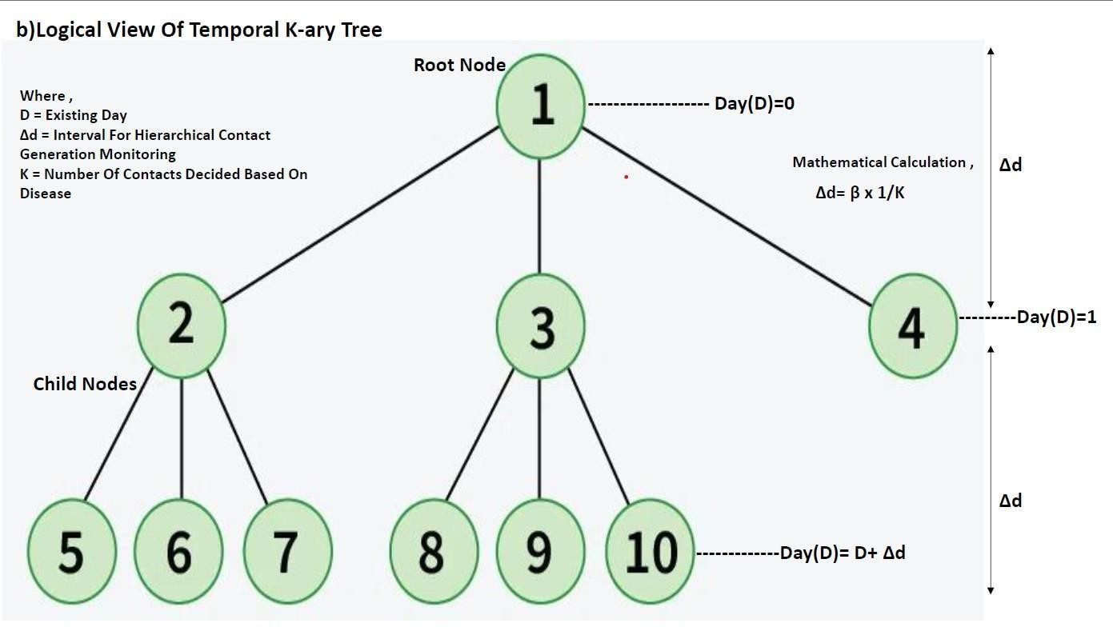
Figure 4.1: Fig-1(Storage View Of Temporal K-ary Tree)
- Storage View: The state of each node (infected, suspected, quarantined) is stored and up- dated as the simulation progresses.

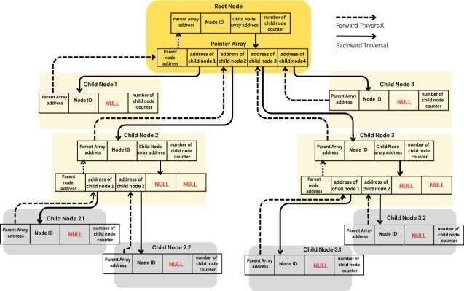
Figure 4.2: Fig-2(Logical View Of Temporal K-ary Tree)

Use-case Diagram
This use case diagram models the interactions between two main actors—Patient and Contact Tracer—with the Contagious Disease System.
Actors:

- Patient: Reports symptoms, follows quarantine rules, and lists people they’ve interacted with.
- Contact Tracer: Performs tracing operations and monitors further spread.

Use Cases:

- Describe Symptoms – The patient provides their health details and visible symptoms.

- Follow Quarantine – The patient follows prescribed isolation procedures.

- Mention Interacted People – The patient lists all individuals they came in contact with.
- Contact Tracing (included use case) – Performed by the system with data from the patient to track the chain of contacts.
- Monitor Contacts – The contact tracer monitors all traced individuals for symptoms or in- fection status.
Include Relationships: Both ”Describe Symptoms” and ”Mention Interacted People” include the Contact Tracing use case, meaning this action is essential to initiate tracing. Contact tracing further leads to Monitor Contacts by the contact tracer.

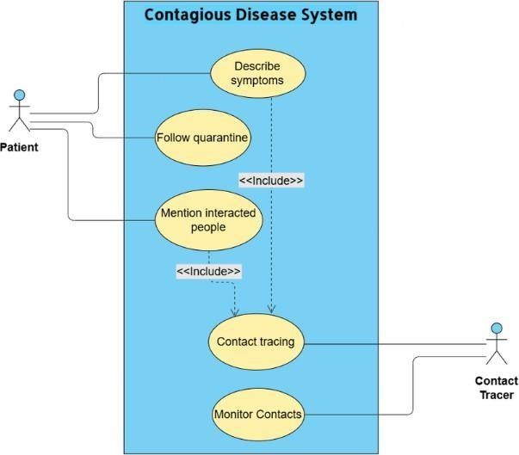
Figure 4.3: Use Case Diagram for Disease Simulation System

Process-flow Diagram
The process-flow illustrates the sequence of actions taken during simulation:

- Infection begins at a source node.
- Infection spreads to K contacts after every ∆d interval.
- Contact tracing identifies the spread chain.
- Quarantine is applied based on infection depth or influence.
- Infected or recovered nodes are removed or marked.

Variables:

- D – Existing Day

- K – Number of contacts per node

- ∆d – Time interval for contact list generation

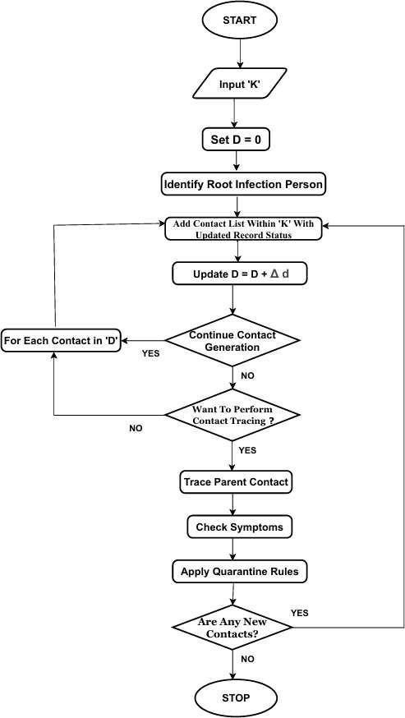
Figure 4.4: Process Flow Diagram of Disease Simulation

Algorithms
Symptom Analyzer: Allows users to input symptoms using checkboxes and custom input fields. Supports quick assessment of individuals for early-stage infection suspicion.
Contact Tracing: Performed using Reverse Depth-First Search (DFS) to trace back the infection path from a given node.
Super-Spreader Detection: Utilizes a Temporal Influence Scoring Algorithm to identify individ- uals with the most downstream impact in the network.
Quarantine Logic: Implemented using the Reverse Influence Blocking Algorithm, targeting nodes whose isolation would most reduce the spread.
State History (Undo/Redo): Maintains simulation steps using Immutable State Save via JSON snapshots, enabling users to revert or replay actions.
Contact Forest Generation: Generates a structured contact tree using Recursive Tree Layout (Top-Down Traversal). Models the infection spread hierarchy through a dynamic K-ary tree struc- ture.
Visualization and UI Controls: Incorporates zooming, scaling, and dynamic color-based infec- tion status.

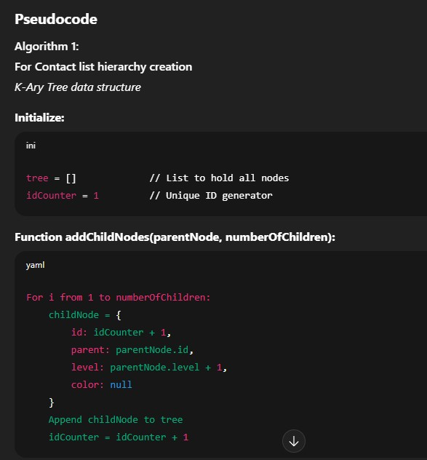
Figure 4.5: Recursive Tree Layout (Top Down Traversal)
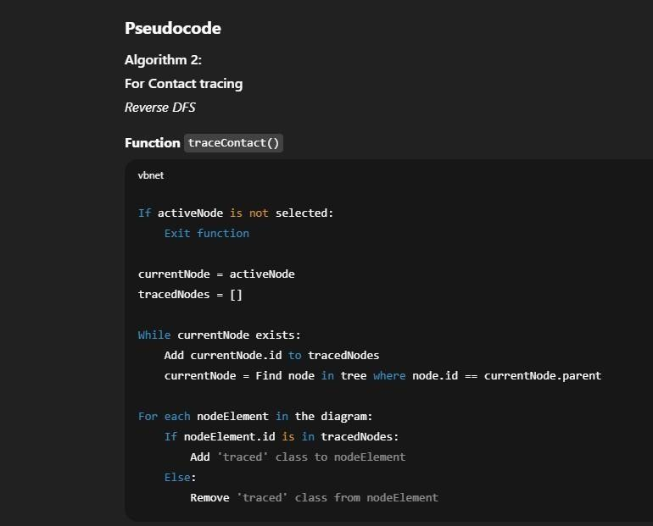
Figure 4.6: Reverse DFS

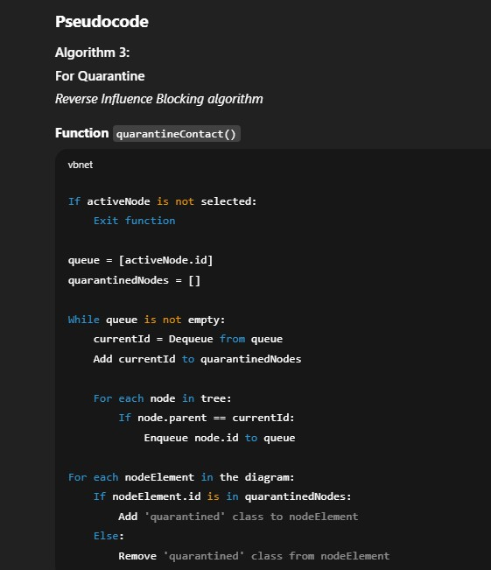
Figure 4.7: Reverse Influence Blocking Algorithm

Implementation Phase

The simulation was developed using modern web technologies including HTML5, CSS3, JavaScript (ES6+), and SVG, ensuring a completely offline, interactive, and responsive tool that models the spread of a contagious disease through a structured contact network.
The entire project is self-contained in a single index.html file, making it easy to distribute and run on any modern browser without the need for a backend, server, or installation.
The epidemic is modeled using a temporal K-ary tree, where:

- Each node represents an individual.

- Each branch models contact spread over discrete time intervals (∆d days).
- Nodes are assigned risk levels and visualized using color codes (Red for high, Yellow for medium, Green for low).

Code Snippet / Simulation Details
The core simulation logic is implemented using JavaScript, and the infection/contact network is dy- namically visualized using SVG (Scalable Vector Graphics). The application runs entirely within a browser without requiring any backend or server-side component.
Key Features:
Interactive Node Addition:
Users can add new individuals to the simulation by providing:

- A custom 12-digit ID (treated as an Aadhaar number for unique identification)

- Selected symptoms

- Measured immunity level (in lymphocytes/mL)

Symptom-Based Risk Classification:
Based on the number of symptoms selected, the system automatically classifies the individual into risk categories.
Node Color Representation:
Each node is color-coded in the SVG diagram to reflect the individual’s health risk status:

- Red – High Risk (Infected)
- Yellow – Medium Risk (Suspected)

- Green – Low Risk (Non-Infected)

- Purple Stroke – Quarantined

- Gold Dashed Stroke – Super-Spreader

These visual cues enable intuitive and real-time tracking of the epidemic spread through the simu- lated contact forest.

- Super-Spreader Detection and Removal: Identifies nodes with the highest number of high- risk children. Removing such nodes converts the K-ary tree into a K-ary forest, effectively isolating infection clusters.
- Contact Tracing: Reverse DFS traversal highlights the path from any node to the infection source.
- Quarantine Logic: Isolates high-risk individuals and their direct contacts, visually marked with purple strokes.
- Undo/Redo History: Allows users to navigate forward/backward through simulation states using JSON snapshots.
- Zoom & Animation Controls: Offers smooth UI interaction, animated simulation playback, and a live day counter based on the depth of the tree.

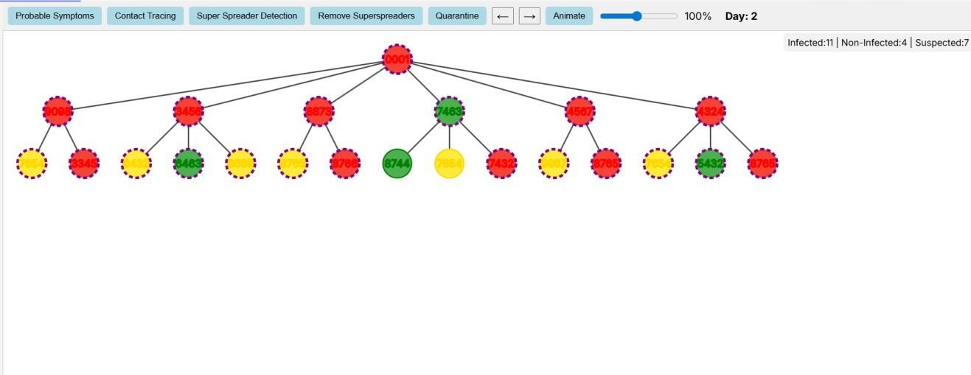
Figure 4.8: Before removing Superspreader
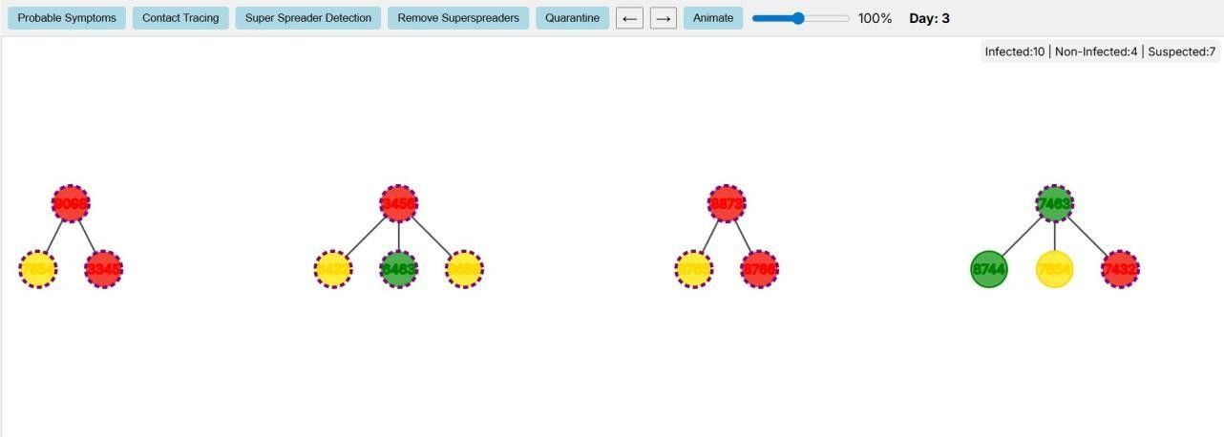
Figure 4.9: After removing Superspreader

The Contagious Disease Portal project adopts a modular client-server architecture, enabling effi- cient interaction between simulation logic, user inputs, and data persistence. It integrates epidemic simulation, contact tracing, and dynamic visualization of infection of our Temporal K-ary Tree model which is working behind this portal.
Frontend (Client-Side):
The frontend is developed using HTML5, CSS3, and JavaScript (ES6+), and is designed to support real-time, dynamic visualizations of the data models. It provides an intuitive interface for:

- User registration and login to access the portal’s features.

- Viewing disease information, government guidelines, and analytical content.

- Interacting with the portal’s tools to understand and visualize contact tracing, quarantine actions, and simulation animations as described in the ”Tools” section.

Backend (Server-Side):

- A Node.js + Express.js backend provides robust support for advanced functionalities.

- It Processes API requests for user authentication, data retrieval, and feedback submission.

- Logs user and system activity for analysis and persistence.

Database (SQLite):
A lightweight SQLite database stores all critical data for the portal and its analytical models:

- User account information (emails, passwords).
- User feedback submissions: Capturing all information from the feedback form (name, email, phone, message) for review.
- Key metrics: Storing values like ”Active Cases” and ”Recovered Cases” that are displayed on the main dashboard.

The portal integrates the frontend and backend through RESTful APIs, ensuring modularity:
User Interaction: Users log in, view content and interact with the analytical tools to understand tracing and quarantine logic.
API Calls (AJAX/Fetch): The frontend sends requests to the backend for data or to trigger ac- tions.
Backend Processing: The backend executes algorithms, authenticates users, and updates the state of the data models.
Response Rendering: The backend returns data in JSON format; the frontend updates the UI to reflect the new information.
Real-Time Feedback: Changes and requested data are reflected instantly in the user interface.

Testing Phase:

During this phase, manual testing was conducted to ensure that the simulation performed as ex- pected in terms of logic, usability, and responsiveness. The focus was on validating both the functional correctness and user experience of the system. Several key features were thoroughly tested:

- Infection Spread and Delay Interval Behavior (Ad): Verified that infections progressed logically over time with the correct temporal spacing.
- Accurate Contact Tracing from Node to Root: Ensured the reverse DFS algorithm cor- rectly traced infection paths.
- Super-Spreader Detection and Removal: Confirmed that nodes with a high number of high-risk children were detected and upon removal, the tree split into multiple independent k-ary forests.
- Undo/Redo Reliability: Tested the consistency of state restoration after multiple simula- tion steps.
- Day Counter Accuracy: Checked for correct updates as infection levels deepened with each level/day.
- Responsive UI and Zoom Interaction: Evaluated smooth user experience while zooming, panning, or interacting with the simulation.
- Color Updates and Status Tracking: Verified that nodes visually reflected their infection risk level (high, medium, low), quarantine status, and super-spreader status.

Outcome:
The system passed all manual functional tests and was observed to be stable and consistent across multiple modern browsers including Google Chrome, Mozilla Firefox, and Microsoft Edge. No crashes or bugs were encountered during testing. The visual transition from a hierarchical tree to a disjoint forest, after the removal of super-spreaders, confirmed the simulation’s logical accuracy and effectiveness in modeling epidemic control.

Deployment Phase:

The deployed Contagious Disease Portal goes beyond a basic informational site, functioning as a vital public health tool. It provides a centralized, multilingual platform with accurate statistics and government-verified guidelines. By offering interactive simulations, it educates users on concepts like contact tracing, quarantine, and infection dynamics. Health officials can use its decision- support features to simulate outbreaks, perform DFS-based contact tracing, and evaluate quarantine strategies. With real-time updates on active and recovered cases, the portal enhances situational awareness. Additionally, it serves as a communication bridge between the public and authorities, fostering trust through structured feedback and engagement.

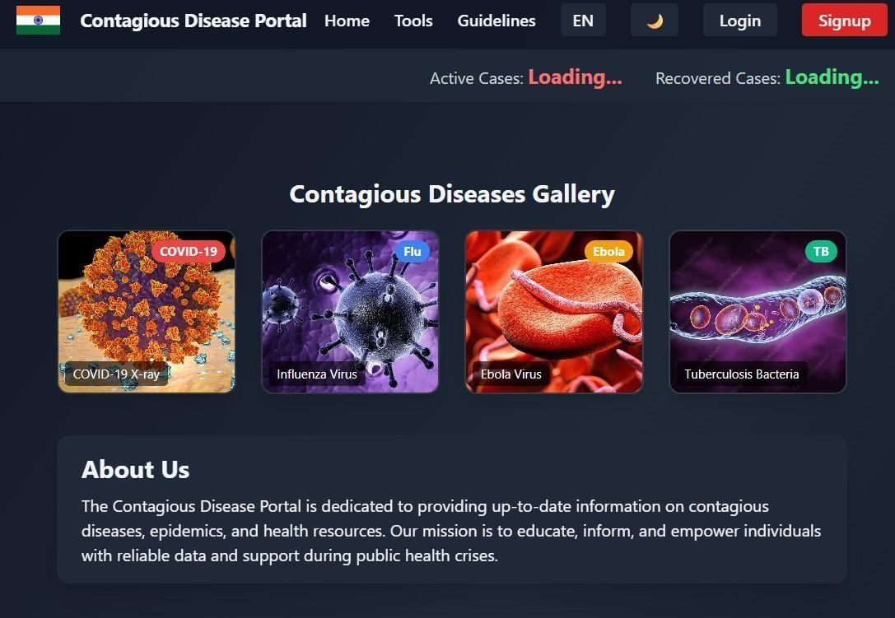
Figure 4.10: GUI of contagious disease portal

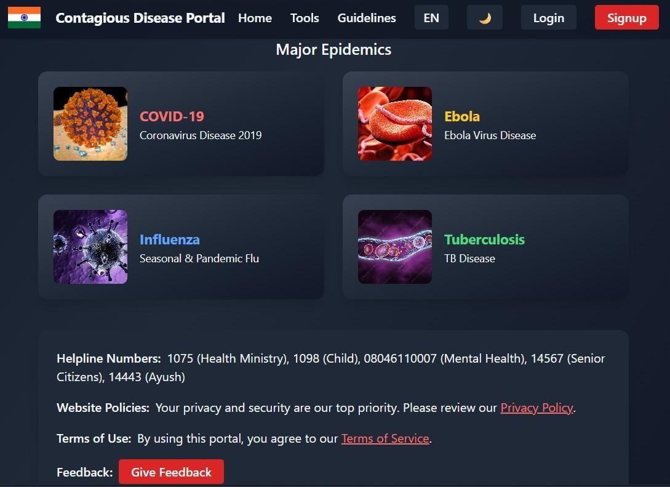
Figure 4.11: GUI of contagious disease portal

Conclusion

The Contagious Disease Simulation Portal successfully demonstrates how interactive technologies and epidemiological modeling can aid in understanding and managing disease outbreaks. By in- tegrating a hierarchical contact tracing system with real-time simulation, the platform provides both educational value and strategic utility. Users can visualize the spread of infection, assess risk levels, and explore the impact of super-spreaders and quarantine measures through an intuitive interface. With its modular architecture, the system allows easy extension to real-world datasets and backend analytics, making it suitable for use by both the general public and health authorities. Overall, the project showcases the potential of combining web technologies with disease modeling to improve public health awareness, decision-making, and emergency response preparedness.

References

- “Contact Tracing Strategies for Infectious Diseases”. Danielle Guy, Petya Kodjamanova, Lena Woldmann, Jyoti Sahota, Melanie Bannister-Tyrrell, Yajna Elouard, Marie-Ame´lie Degail, PLOS Global Public Health, year 2025.
- “Simulation of COVID-19 Spread Using Contact Networks and Graph Theory”. R. Gupta, A. Patel, Journal of Computational Biology, vol. 28, year 2021.
- “Contact Tracing Algorithms and COVID-19 Control Strategies”. H. Salathe´, C. L. Althaus, Nature Medicine, vol. 26, year 2020.
- “COVID-19 India Dataset”, Ministry of Health and Family Welfare (MoHFW), Government of India, year 2021.
- “A Simplicial Epidemic Model for COVID-19 Spread Analysis”. Y. Chen et al., Proceedings of the National Academy of Sciences, vol. unspecified, year 2024.

